**Eduardo Guzman, Assignment 4, CSC-155, Section 2, Spring 2023**

1. 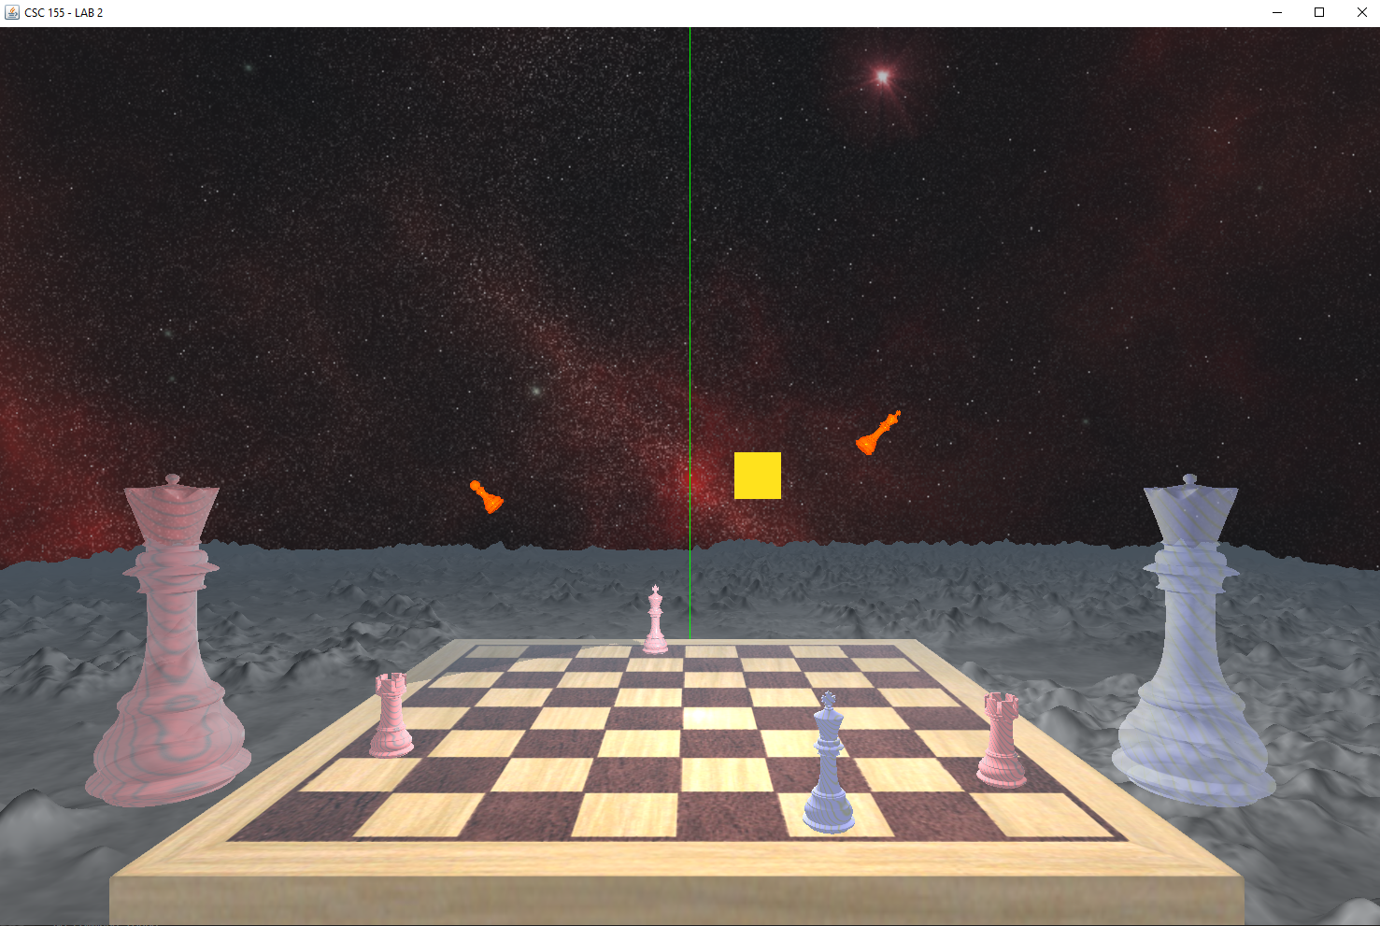

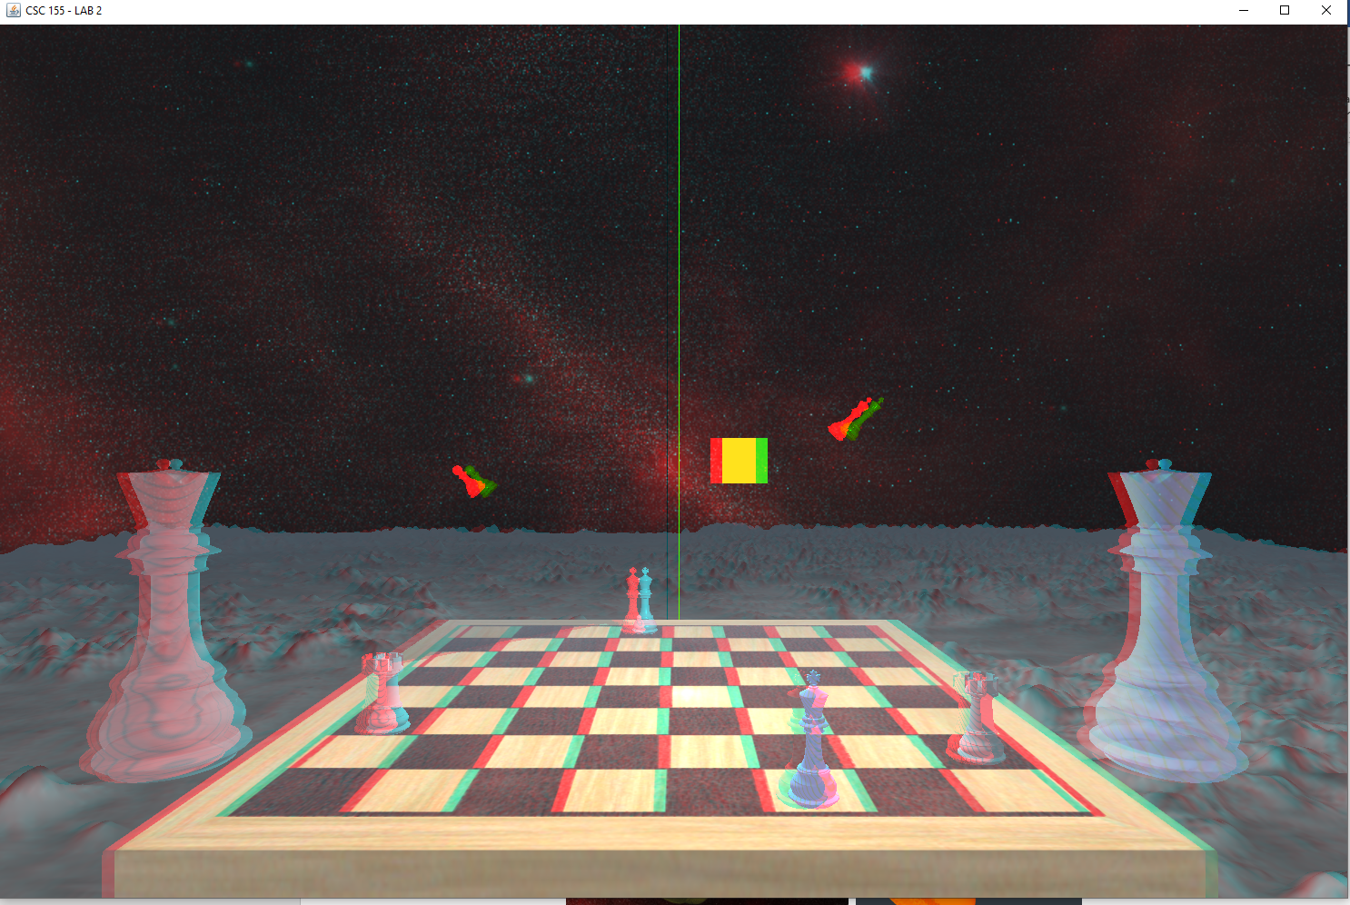

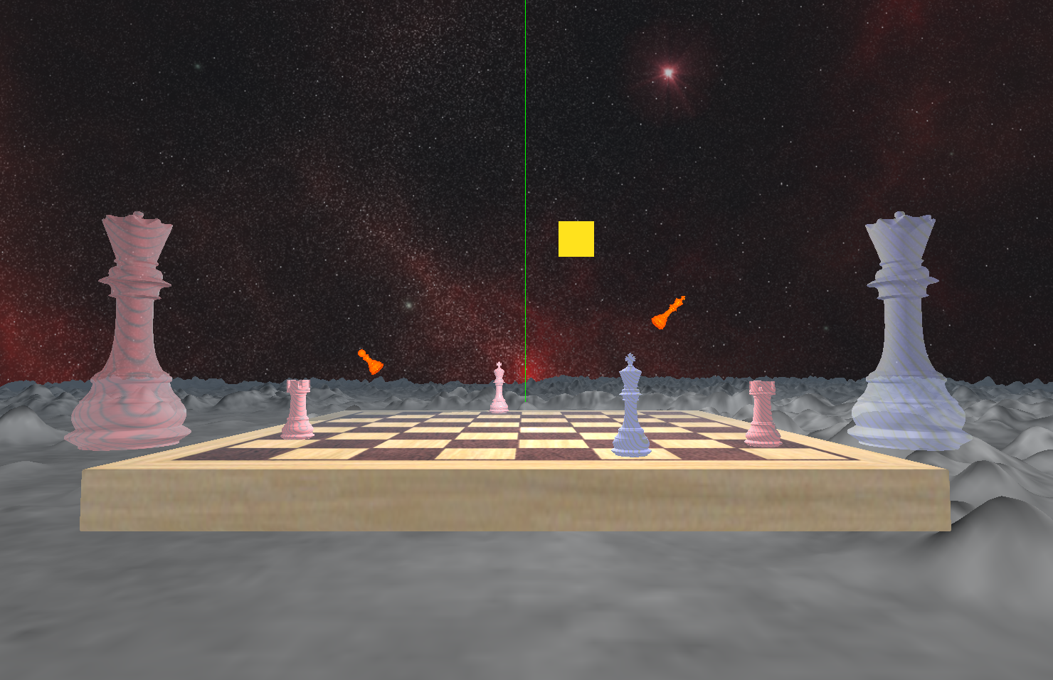

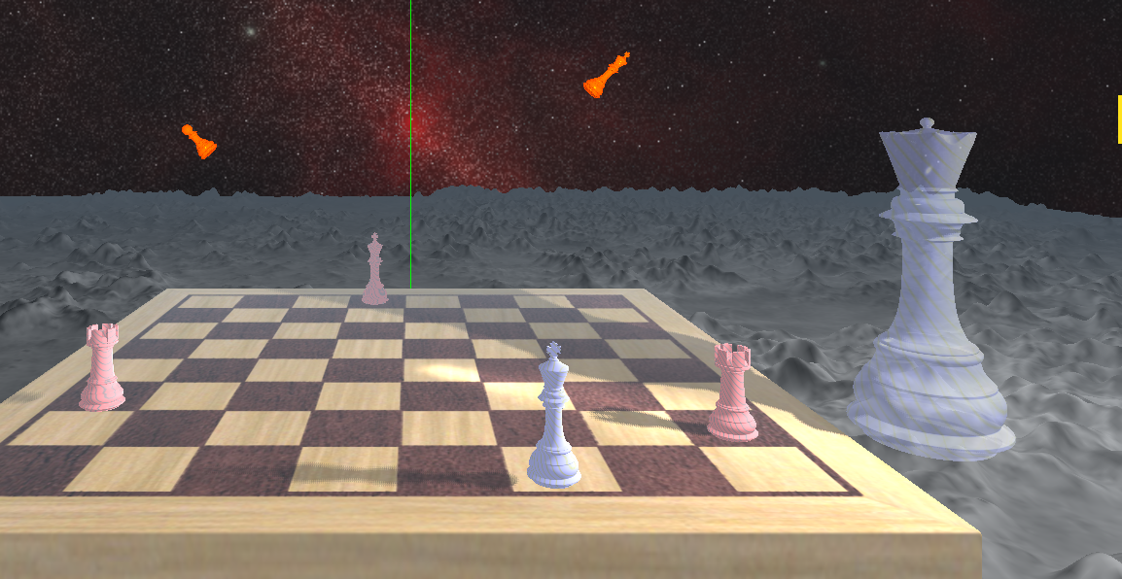

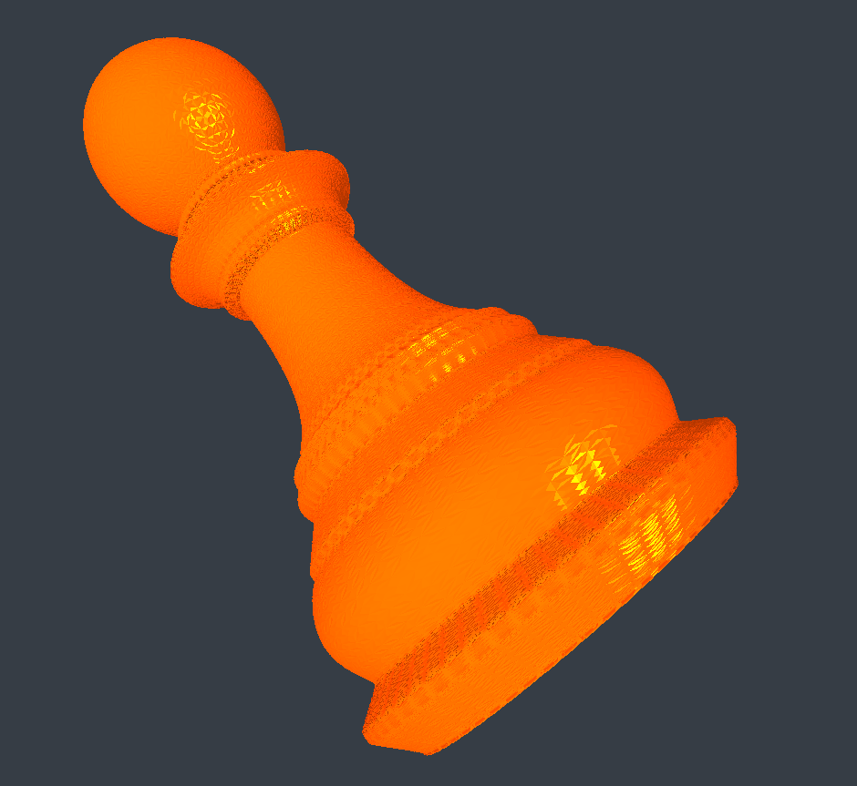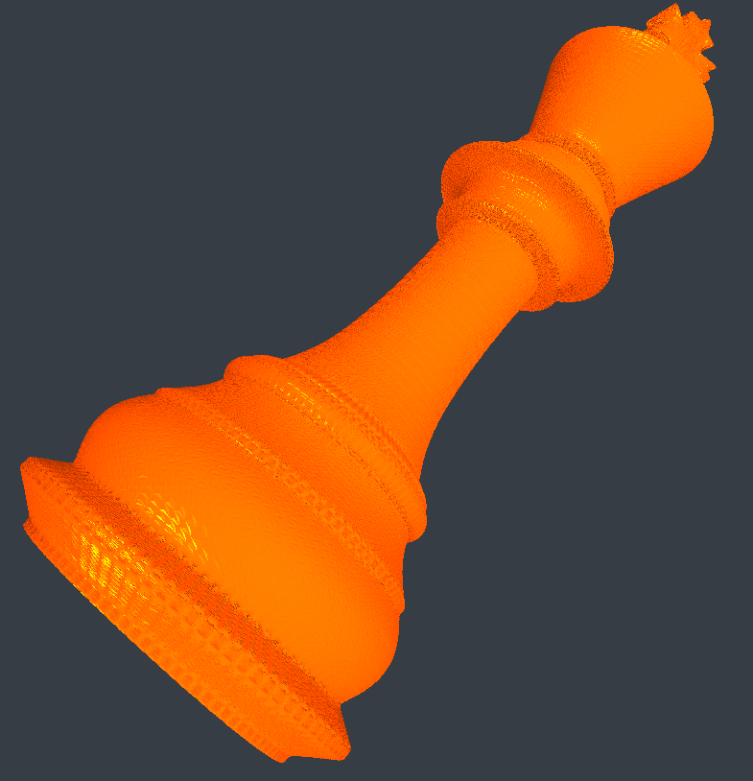

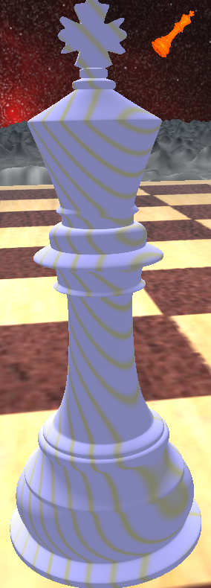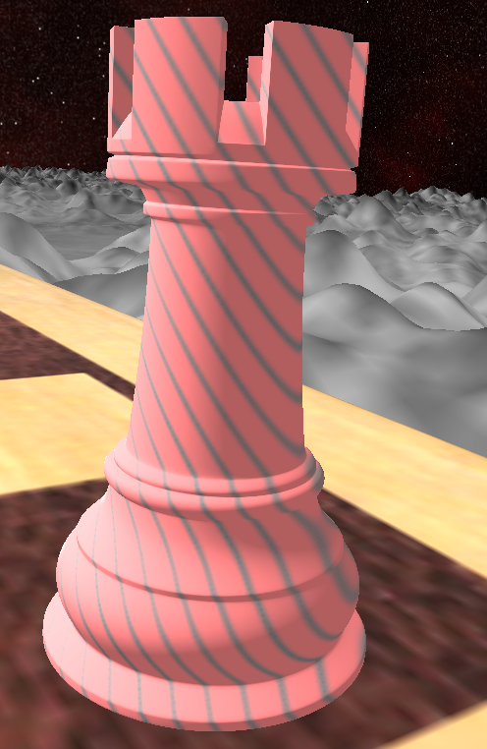

1. **a brief description of your scene**
   * My vision for this scene was a checkmate scene. If you look closely, there is a checkmate move for red. They are at war and the two queens to the sides are ghosts, watching helplessly. Their transparency is intended to create the ghost effect. The mood/theme is in space and the board is sitting on a moon like surface. There are also some stars, in the shape of a king and pawn far in the distance floating in space.
2. **a list of which objects participate in shadow-mapping**
   * All objects in the 3D chess board participate in shadow mapping
   * The rook, the kings, and the blended/transparent Queens participate in shadow mapping
3. **a list of the five features you chose to implement, clearly describing how to recognize them**
   * **Tessellation Shader + Height Map (1.0)**
     1. The plane below the chess board that is gray is rendered through the tessellation shader with height map images
     2. It has a moon like texture and height map that ties the scene better to the space skybox.
     3. The “T” keyboard key will toggle the tessellation shader
   * **Fog (0.5)**
     1. Fog is implemented into the whole scene except the lights, axis lines, shadows, and the geometry shader items.
     2. The above items have their own shader programs and fog was not implemented into those shaders. It was added to desired ones.
     3. I wanted the geometry shader items to show their detail in depth when viewed, even from afar.
     4. When moving away from the board, the fogColor will take more and more effect
   * **Blending Transparency (0.5)**
     1. The queens to the left and right of the board participate in blending transparency and going around the items will show the transparency
   * **3D texture && Perlin Noise (1.0)**
     1. The chess pieces closest to the board participate in Perlin Noise and they help distinguish between the two enemies on the board
   * **Stereoscopy with red/cyan glasses (1.0)**
     1. The keyboard key ‘Y’ will be used to toggle the Anaglyphs with red/cyan glasses
     2. It is turned off by default, but it can be enabled
   * **Geometry Shader (1.0)**
     1. Two chess pieces will render in the back, like stars, and they will have added vertices interpolated into them
4. **a list of user controls (such as for moving the camera or light(s)):**
   * **Inputs for moving the Camera:**
     1. “A”: Moves the camera left (strife).
     2. “D”: Moves the camera right (strife).
     3. “W”: Moves the camera forward.
     4. “S”: Moves the camera backwards.
     5. “Q”: Moves the camera down.
     6. “E”: Moves the camera down.
     7. “Left arrow”: Pan the camera left;
     8. “Right arrow”: Pans the camera right;
     9. “Up Arrow”: Pitches the camera up.
     10. “Down arrow”: Pitches the camera down.
   * **Inputs for moving the Light:**
     1. “Mouse Drag Up”: Moves the light in the -Z-direction.
     2. “Mouse Drag Down”: Moves the light in the +Z-direction.
     3. “Mouse Drag Left”: Moves the light in the -X-direction.
     4. “Mouse Drag Right”: Moves the light in the +X-direction.
     5. “Mouse Wheel scroll up”: Moves the light in the +Y direction.
     6. “Mouse Wheel scroll down”: Moves the light in the -Y direction.
   * **Other Inputs:**
     1. “Esc”: Shuts down the scene
     2. “Space”: toggles the XYZ lines
     3. “T”: Toggles the tessellation shader
     4. “Y” Toggles the 3D Anaglyphs
5. **a list of which requirements you were NOT able to get fully working**
   * All requirements have been met
6. **a list of any features you implemented that went beyond the assignment requirements**
   * Unsure if any features went beyond the requirements…
7. **Source information for files:**
   * **I was left a comment on my previous homework about not using models from free3D because of the potential issue of distributing the object file from the site directly. I spoke to the professor about what I could do and we came to an agreement that I could import the objects into my Blender software and export a different obj. The site allows me to use the model for any personal use and I changed things around the model so it would not be the exact same. I also exported the objects to export with triangular mesh. I believe I have satisfied the requirement from the professor.**
   * **Textures** 
     1. **Skybox Cube Map**
        + assets/cubeMaps/space/red
        + <https://opengameart.org/content/space-skyboxes-0>
     2. **Chess Board Texture**
        + assets/textures/chess/WoodenChessBoard_diffuse.jpg
        + <https://free3d.com/3d-model/woodenchessboard-v1--783762.html>
     3. **Tessellation Shader Texture Map:**
        + assets/textures/moonMap/squareMoonMap.jpg
        + retrieved from Book Program files
     4. **Tessellation Shader Height Map:**
        + assets/textures/moonMap/squareMoonBump.jpg
        + retrieved from Book Program files
     5. **Tessellation Shader Normal Map Map:**
        + assets/textures/moonMap/squareMoonNormal.jpg
        + retrieved from Book Program files
     6. **3D Texture/Marble Noise:**
        + Mostly similar to the one from Book program files
   * **Models**
     1. **Chess Board**
        + **assets/models/chess/Board_HalfSize2.obj**
        + <https://free3d.com/3d-model/woodenchessboard-v1--783762.html>
     2. **Chess Piece – King**
        + **assets/models/chess/King.obj**
        + <https://free3d.com/3d-model/woodenchesskingsidea-v1--60100.html>
     3. **Chess Piece – Queen**
        + **assets/models/chess/Queen2.obj**
        + <https://free3d.com/3d-model/woodenchessqueensidea-v1--894583.html>
     4. **Chess Piece – Rook**
        + **assets/models/chess/Rook.obj**
        + <https://free3d.com/3d-model/woodenchessrooksideb-v2--120548.html>
     5. **Chess Piece – Pawn**
        + **assets/models/chess/Pawn.obj**
        + <https://free3d.com/3d-model/woodenchesspawnsidea-v1--434515.html>
     6. **Skybox**
        + The Cube.java from the Program files was used for the skybox
   * **Materials**
     1. Gold materials from the book was used
     2. ChatGPT was used to generate material values for an amethyst-like characteristics, moon-like characteristics, and star-like characteristics
8. **Name of RVR-5029 Computers:**
   * HALO, TETRIS